Aim: use wireshark to capture network traffic and analyze

Theory:

Wireshark is very similar to tcpdump, but has a graphical front-end and integrated sorting and filtering options Wireshark lets the user put network interface controllers into promiscuous mode (if supported by the network interface controller), so they can see all the traffic visible on that interface including unicast traffic not sent to that network interface controller's MAC address. However, when capturing with a packet analyzer in promiscuous mode on a port on a network switch, not all traffic through the switch is necessarily sent to the port where the capture is done, so capturing in promiscuous mode is not necessarily sufficient to see all network traffic. Port mirroring or various network taps extend capture to any point on the network. Simple passive taps are extremely resistant to tampering

Steps:

Step 1:

Open wireshark

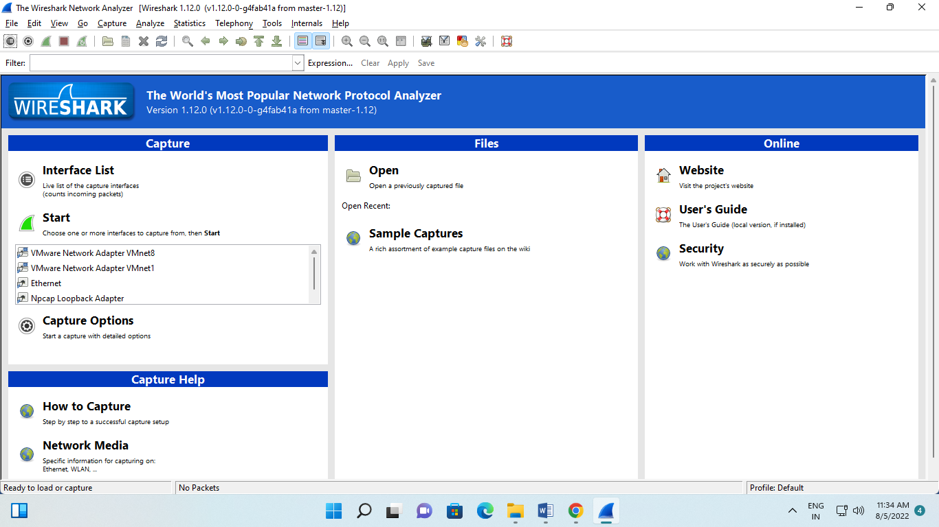

Step2:

Select on interface list

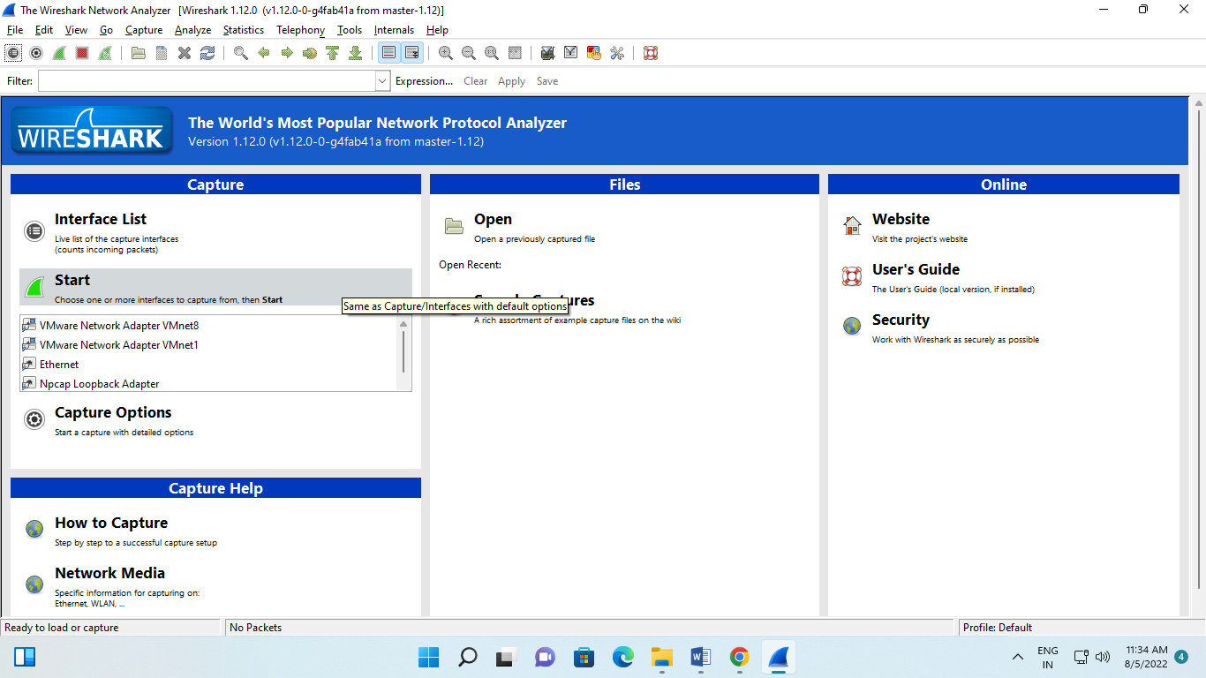

Step 3:

Select the Ethernet and click on start

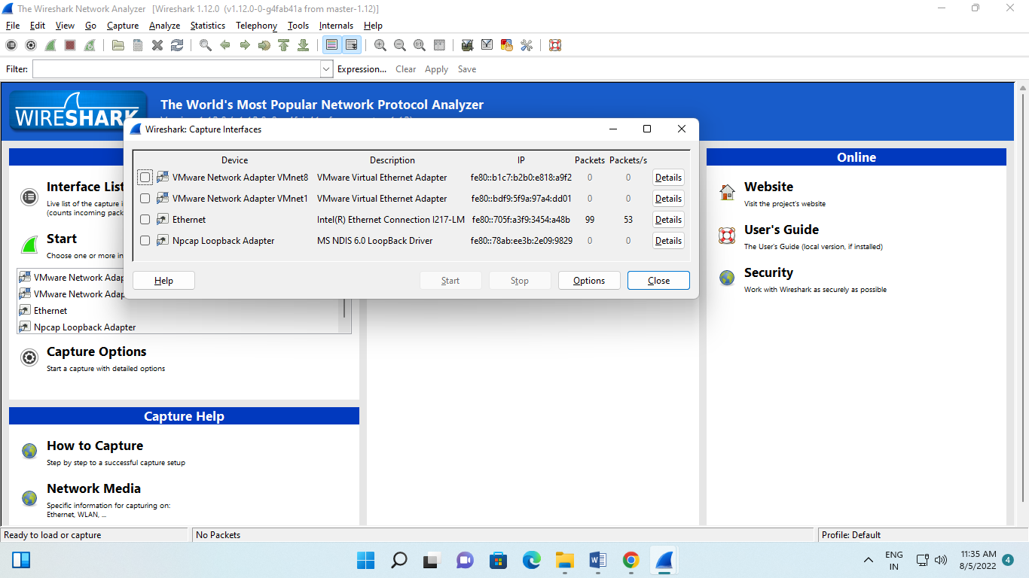

Step4:

Go to chrome and and then got techpanda.org submit the credentials

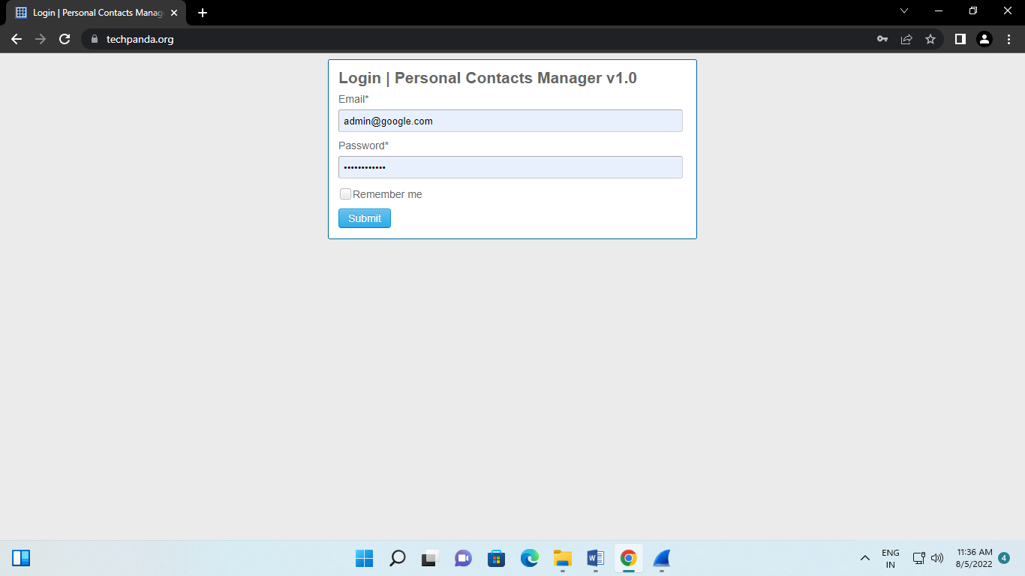

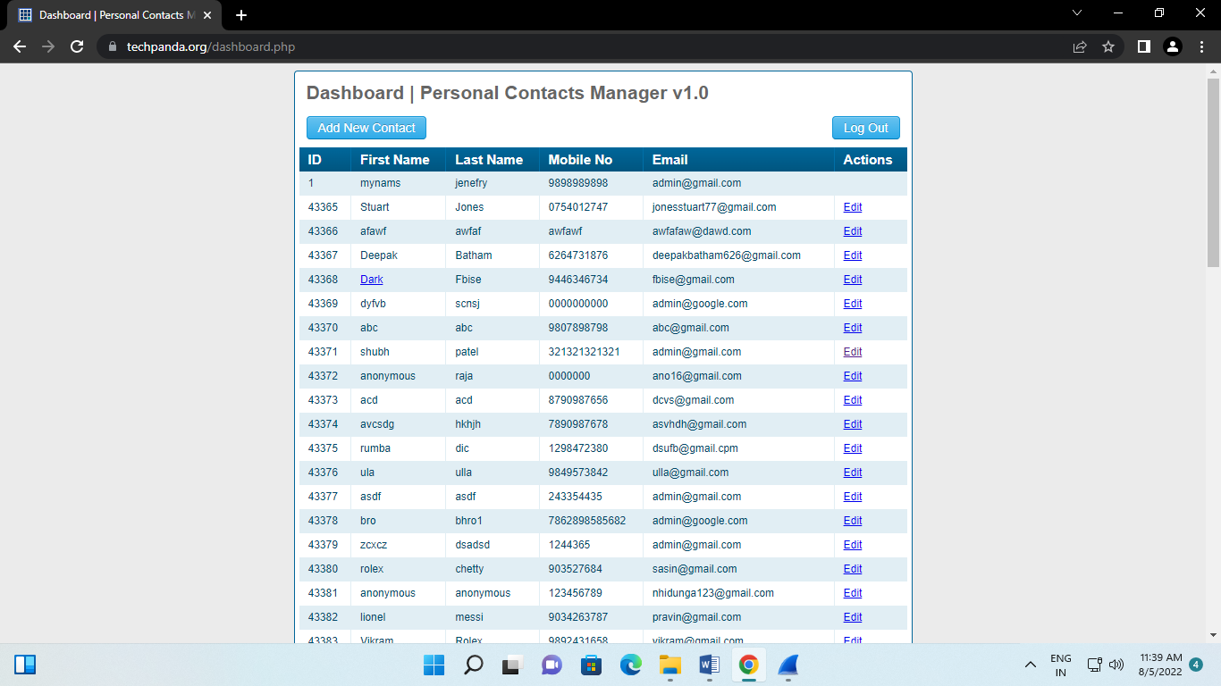

Output

Go to wireshark and check the ip of the website

